Proposal Annexure for
Development of software for
Integrated Manuscript, Digitization, Cataloguing & Management System

Introduction
Knowledge Management is an process by which wealth or value is generated (intangible or tangible) from intellectual or knowledge based assets.
Why Knowledge Management in the area of Manuscripts?
  - Manuscript is a Knowledge Based Asset of our Nation
  - Lakhs of Manuscripts are available with different stakeholders
  - Enormous amount of knowledge present in these
  - Need to minimize the process - time gap between the possessor of manuscript and the user of knowledge in the manuscript
  - Need a common platform for harnessing, dissemination and application of the knowledge present in these manuscripts.

Layers of Knowledge Management
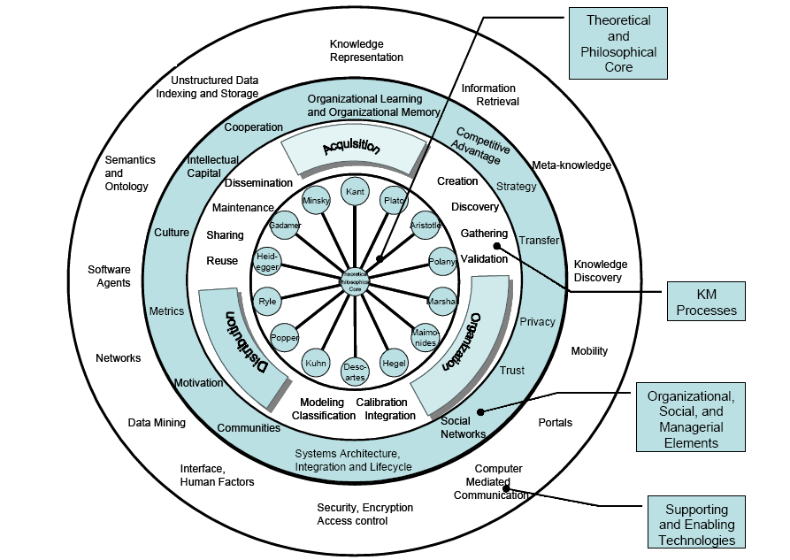

Manuscript Life cycle
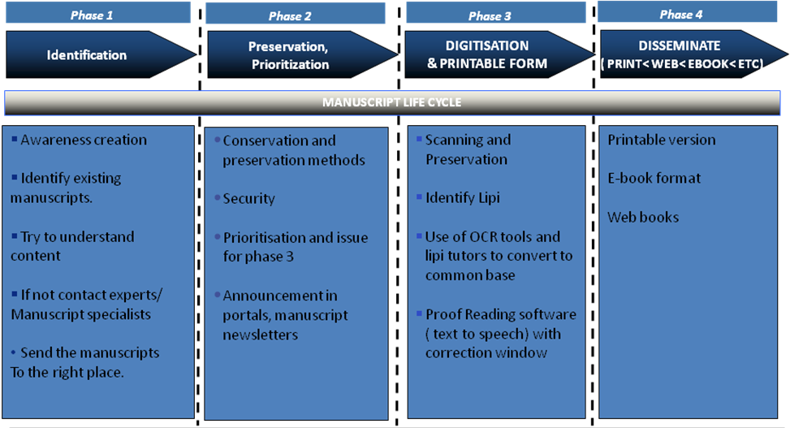

Role of IT systems

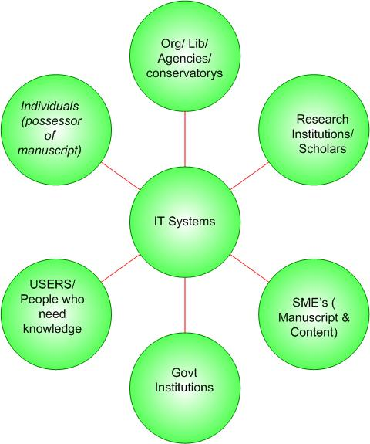

Technical Considerations

A digitization project includes the “basic processes - creation, storage, and management. There are components to the digitization project:
- Image creation deals with the initial capture or conversion of a document or object into digital form, typically with a scanner. There may then be one or more file or image processing steps applied to the initial image, which may alter, add, or extract data. Processing will include image editing (scaling, compression, sharpening, etc.) and metadata creation.
- File management refers to the organization, storage, and maintenance of images and related metadata.
- Image delivery incorporates the process of getting images to the user and encompasses networks, display devices, and printers.
The tasks needed to address the above components:

- Selecting items
- Recording items going to digitization
- Preparing items for digitization
- Digitization of items
- Recording digitization method and attributes (color and scale reference)
- Naming image file
- Saving image file
- Recording image file location
- Returning items to archival storage
- Recording items returned
- Noting image file creation

Digitization Project Considerations:
- The technology necessary to complete the digitization consists mainly of hardware, software, and networks.
- Protocols and standards, policies and procedures required for workflow, maintenance, security, upgrades, etc.
Considerations that will affect decisions about the technical infrastructure include:
- Quality requirements based on document attributes
  - Assessing document attributes (detail, tone, color)
  - Defining the needs of current and future users
  - Objectively characterizing relevant variables (e.g., size of detail, desired quality, resolving power of system)
  - Correlating variables to one another via formulas
  - Confirming results through testing and evaluation

- Resource Management
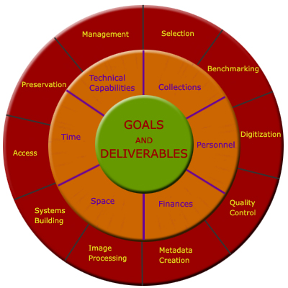
  - The figure demonstrates the organic nature of digital imaging, with interdependencies connecting goals, resources, and processes.

- User Needs
  - File format and compression used
  - Web browser capabilities
  - Network connections
  - Scaling routines and programs
  - End user computer and display capabilities

- Setting long-term preservation plans like:
  - Retaining the physical reliability of the image files, accompanying metadata, scripts, and programs (e.g., make sure that the storage medium is reliable with back-ups, maintain the necessary hardware and software infrastructure to store and provide access to the collection)
  - Ensuring continued usability of the digital image collection (e.g., maintain an up-to-date user interface, enable users to retrieve and manipulate information to meet their information needs)
  - Maintaining collection security (e.g., implement strategies to control unauthorized alteration to the collection, develop and maintain a rights management program for fee-based services)

The Need and Requirements Summary
The high level requirements and scope of this project includes
Design, Develop and Deploy an integrated web based multilingual manuscript digitisation and management system whose scope and components includes the following
- Ability to categorise manuscripts. ( A standard coding and categorization system to be evolved)
- Digitisation and online storage ( hardware interface tool with software )
- High level summary of digitized manuscripts through manuscript data system
- Creation of Search Engine – multilingual search, archiving, executive summary search, key word search and other advanced search options
- Integration with existing OCR tools
- A text to speech engine ( proof reading software) with a correction window
- Conversion of the edited text version to e- book version
Other features that could be included in web based tool would be
- Web based collaboration platform through which stakeholders can disseminate knowledge ( discussion forms, discussion about a particular manuscript, news and events about a manuscript, manuscript wiki, manuscript newsletter)
Scope Exclusions : 1) Creation of a separate OCR tool
2) All hardware necessary for the above like scanning equipment, etc

Architecture

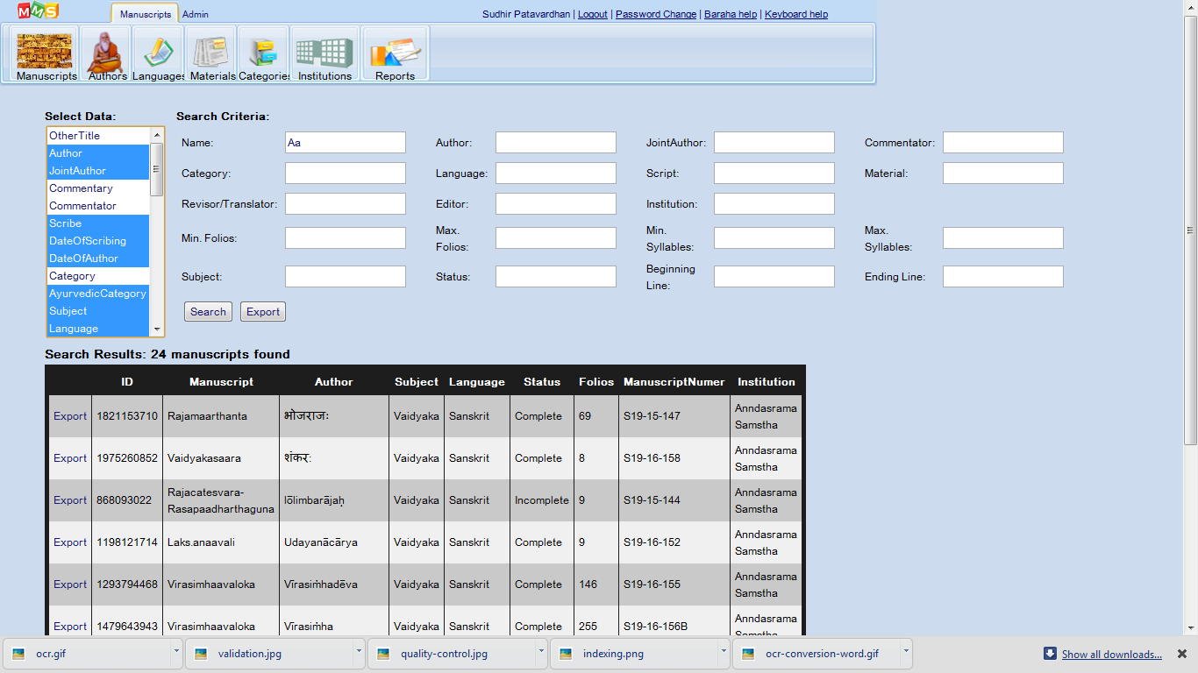
Data Access
Search Engine
Catalog Management
Archival

OCR
OCR

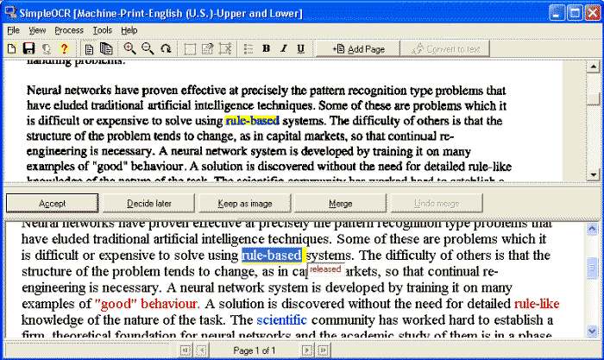
Text to Speech
Audio Visual Proof Reading

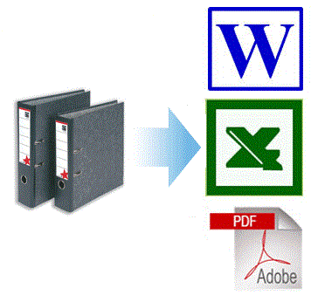
Proof reading

Validation
Quality Checklist


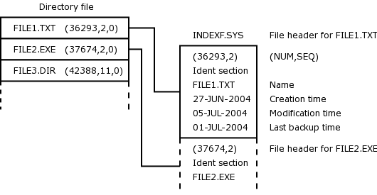
Storage, Indexing and Metadata
Forms for Metadata
Index Creation
Storage and Organization

Scanning
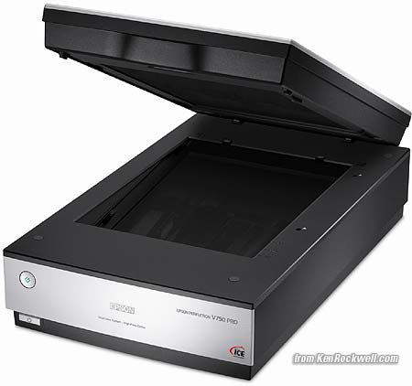
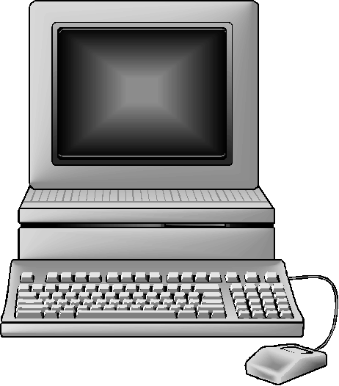
Scanner Drivers
Routing

Batch 1
Batch 2
Batch n
Inventory, Coding
and Preparation
Inventory and Workflow

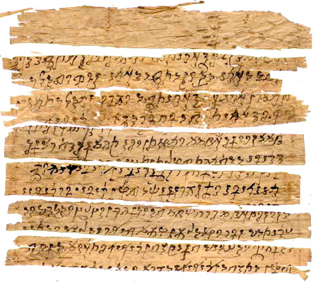
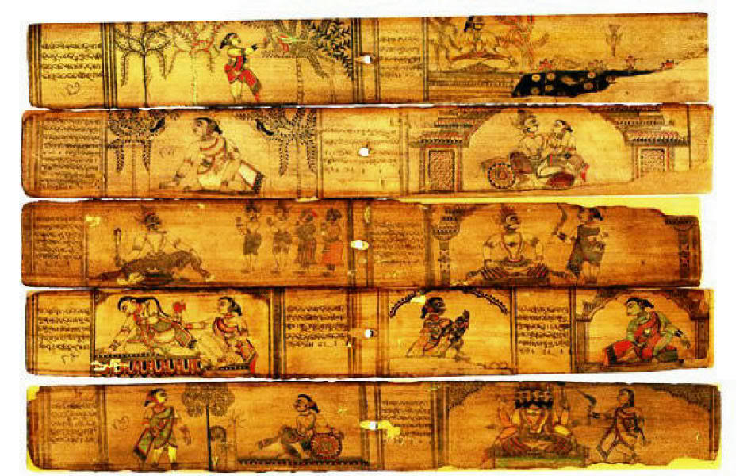

Software Architecture
Web Apps
Desktop Tools
vv
Open Platforms
Common Toolset (Persistence, Text-To-Speech Engine, OCR ..)
Inventory
Batch Packaging
Tracking
Search Engine
e-Book
Workflow
Digitization, File Mgmt, Indexing
OCR + Proof reading
Catalog Management

Schedule of Implementation

Technology and System Requirements
  - Web Platform
  - Apache/Tomcat
  - My-Sql

Technology and System Requirements -
- Hosting during development phase will be at FRLHT.
- Server for hosting the application and database.

Project Schedule
All the tasks associated with this part of the project will be completed in a period of One year as follows:

ACTIVITY | Start | Duration(days)
Manuscripts Digital Repository | 06-05-13 | 98 | 18-09-13
Specification | 06-05-13 | 30 | 14-06-13
Mockups and User Stories | 06-05-13 | 10 | 17-05-13
Use Cases | 06-05-13 | 5 | 24-05-13
User Requirement Specification | 20-05-13 | 5 | 31-05-13
User Acceptance Test Plan | 27-05-13 | 5 | 07-06-13
Review by project board | 03-06-13 | 5 | 14-06-13
Approval by project board | 10-06-13 | 0 | 14-06-13
Blueprint | 14-06-13 | 7 | 25-06-13
Existing Tools Evaluation | 17-06-13 | 7 | 25-06-13
Evaluation | 17-06-13 | 7 | 25-06-13
Required features List | 17-06-13 | 7 | 25-06-13
Workflow | 17-06-13 | 1 | 17-06-13
Scanning, Digitization & Storage | 17-06-13 | 1 | 17-06-13
Document Archiving & indexing | 17-06-13 | 1 | 17-06-13
Categorizing (Meta-data mgmt) | 17-06-13 | 1 | 17-06-13
Catalog Management | 17-06-13 | 1 | 17-06-13
Proof-reading | 17-06-13 | 1 | 17-06-13
Editing & Publishing | 17-06-13 | 1 | 17-06-13
Workflow Management | 17-06-13 | 6 | 24-06-13
Define WF | 17-06-13 | 1 | 17-06-13
Change WF Definition | 17-06-13 | 1 | 17-06-13
Maintain WF Items (add/change/remove/assign) | 17-06-13 | 1 | 18-06-13
Track WF items | 18-06-13 | 1 | 18-06-13
Dashboards | 18-06-13 | 1 | 19-06-13
WF Item queues | 19-06-13 | 1 | 19-06-13
WF Item Routing | 19-06-13 | 1 | 19-06-13
Pending items | 19-06-13 | 1 | 19-06-13
Integration with outside tools & Apps | 19-06-13 | 1 | 20-06-13
Metrics/Reports | 20-06-13 | 2 | 24-06-13
Text-to-Speech Engine | 21-06-13 | 3 | 19-06-13
Multi-lingual Scripts | 17-06-13 | 3 | 19-06-13
Search Engine (multi-lingual) | 17-06-13 | 3 | 19-06-13
OCR (Indian Scripts - Old & New) | 17-06-13 | 7 | 25-06-13
Avalaible tools list (4 or 5 tools) | 17-06-13 | 4 | 20-06-13
Available features List | 17-06-13 | 4 | 20-06-13
Buy-or-Build analysis | 17-06-13 | 3 | 19-06-13
Costs | 17-06-13 | 1 | 17-06-13
Selected Tools | 17-06-13 | 1 | 17-06-13
Tool Integration Plan | 17-06-13 | 3 | 19-06-13
Buy-or-build decision | 17-06-13 | 0 | 17-06-13
Detailed Design | 17-06-13 | 30 | 06-08-13
Use Case Specifications | 26-06-13 | 3 | 28-06-13
Class Design (OO) | 26-06-13 | 10 | 09-07-13
Database Design | 26-06-13 | 7 | 04-07-13
Module Specification/Design | 26-06-13 | 20 | 06-08-13
Workflow | 10-07-13 | 2 | 11-07-13
Scanning, Digitization & Storage | 10-07-13 | 1 | 10-07-13
Document Archiving & indexing | 10-07-13 | 1 | 10-07-13
Categorizing (Meta-data mgmt) | 10-07-13 | 2 | 11-07-13
Catalog Management | 10-07-13 | 2 | 11-07-13
Proof-reading | 10-07-13 | 1 | 10-07-13
Editing & Publishing | 10-07-13 | 2 | 11-07-13
Workflow Management | 10-07-13 | 10 | 23-07-13
Define WF | 10-07-13 | 2 | 11-07-13
Change WF Definition | 10-07-13 | 2 | 11-07-13
Maintain WF Items (add/change/remove/assign) | 10-07-13 | 2 | 11-07-13
Track WF items | 10-07-13 | 1 | 10-07-13
Dashboards | 10-07-13 | 2 | 11-07-13
WF Item queues | 10-07-13 | 1 | 10-07-13
WF Item Routing | 10-07-13 | 1 | 10-07-13
Pending items | 10-07-13 | 2 | 11-07-13
Integration with outside tools & Apps | 10-07-13 | 5 | 18-07-13
Text-to-Speech Engine | 10-07-13 | 10 | 23-07-13
Multi-lingual Scripts | 10-07-13 | 20 | 06-08-13
Search Engine (multi-lingual) | 10-07-13 | 20 | 06-08-13
OCR (Indian Scripts - Old & New) | 10-07-13 | 20 | 06-08-13
UML Diagrams | 10-07-13 | 9 | 06-08-13
Classes | 10-07-13 | 3 | 22-07-13
State Charts | 15-07-13 | 3 | 12-07-13
Action Sequences | 18-07-13 | 3 | 17-07-13
Collaboration diagrams | 18-07-13 | 3 | 22-07-13
System Build | 06-08-13 | 20 | 22-07-13
Module coding/unit testing | 07-08-13 | 7 | 03-09-13
Workflow | 07-08-13 | 2 | 15-08-13
Scanning, Digitization & Storage | 07-08-13 | 1 | 08-08-13
Document Archiving & indexing | 07-08-13 | 1 | 07-08-13
Categorizing (Meta-data mgmt) | 07-08-13 | 2 | 07-08-13
Catalog Management | 07-08-13 | 2 | 08-08-13
Proof-reading | 07-08-13 | 1 | 08-08-13
Editing & Publishing | 07-08-13 | 2 | 07-08-13
Workflow Management | 07-08-13 | 7 | 08-08-13
Define WF | 07-08-13 | 2 | 15-08-13
Change WF Definition | 07-08-13 | 2 | 08-08-13
Maintain WF Items (add/change/remove/assign) | 07-08-13 | 2 | 08-08-13
Track WF items | 07-08-13 | 1 | 08-08-13
Dashboards | 07-08-13 | 2 | 07-08-13
WF Item queues | 07-08-13 | 1 | 08-08-13
WF Item Routing | 07-08-13 | 1 | 07-08-13
Pending items | 07-08-13 | 2 | 07-08-13
Integration with outside tools & Apps | 09-08-13 | 5 | 08-08-13
Metrics/Reports | 07-08-13 | 7 | 15-08-13
Text-to-Speech Engine | 07-08-13 | 20 | 15-08-13
Multi-lingual Scripts | 07-08-13 | 20 | 03-09-13
Search Engine (multi-lingual) | 07-08-13 | 20 | 03-09-13
OCR (Indian Scripts - Old & New) | 07-08-13 | 20 | 03-09-13
System Tests | 07-08-13 | 10 | 03-09-13
Test Summaries and Reports | 21-08-13 | 5 | 20-08-13
Release Approval | 06-08-13 | 0 | 27-08-13
User Acceptance | 04-09-13 | 7 | 06-08-13
UAT Runs | 04-09-13 | 5 | 12-09-13
UAT Reports | 11-09-13 | 1 | 10-09-13
UAT Review | 12-09-13 | 1 | 11-09-13
UAT approval | 12-09-13 | 0 | 12-09-13
Deployment | 13-09-13 | 2 | 12-09-13
Infrastructure | 13-09-13 | 1 | 16-09-13
Implementation | 13-09-13 | 1 | 13-09-13
Test and Reports | 16-09-13 | 1 | 16-09-13
Project Closure Report | 17-09-13 | 2 | 16-09-13
Closure Report Approval | 13-09-13 | 0 | 18-09-13
Support | 10-07-13 | 2 | 11-07-13
User Guides/Help | 17-09-13 | 30 | 13-09-13
Training | 17-09-13 | 10 | 28-10-13
Help Desk | 01-10-13 | 4 | 30-09-13

Project Effort and Cost
Resource | Effort(hrs) | Rate/Hr | Rate/Month | Overall Cost
Project Manager | 56 | ₹ 1,000 | ₹ 1,76,000 | ₹ 56,000
Release Approval | 0
Project Closure Report | 16
Review by project board | 40
Management | 392 | ₹ 1,000 |  | ₹ 3,92,000
System Analyst | 344 | ₹ 900 | ₹ 1,58,400 | ₹ 3,09,600
Define WF | 4
Change WF Definition | 4
Maintain WF Items (add/change/remove/assign) | 4
Track WF items | 4
WF Item queues | 4
WF Item Routing | 4
Pending items | 8
Metrics/Reports | 16
Integration with outside tools & Apps | 8
Search Engine (multi-lingual) | 24
OCR (Indian Scripts - Old & New) | 56
Available features List | 32
Costs | 8
Selected Tools | 8
Use Cases | 40
User Requirement Specification | 40
Mockups and User Stories | 80
System Architect | 624 | ₹ 800 | ₹ 1,40,800 | ₹ 4,99,200
Define WF | 16
Change WF Definition | 16
Maintain WF Items (add/change/remove/assign) | 16
Track WF items | 8
WF Item queues | 8
WF Item Routing | 8
Pending items | 16
Metrics/Reports | 80
Search Engine (multi-lingual) | 160
OCR (Indian Scripts - Old & New) | 160
Use Case Specifications | 24
Class Design (OO) | 80
UML Diagrams | 8
Tool Integration Plan | 24
Database Architect | 56 | ₹ 700 | ₹ 1,23,200 | ₹ 39,200
Database Design | 56
Test Manager | 88 | ₹ 700 | ₹ 1,23,200 | ₹ 61,600
Test Summaries and Reports | 40
UAT Reports | 8
User Acceptance Test Plan | 40
Senior Developer | 920 | ₹ 700 | ₹ 1,23,200 | ₹ 6,44,000
Scanning, Digitization & Storage | 8
Document Archiving & indexing | 8
Categorizing (Meta-data mgmt) | 8
Catalog Management | 8
Proof-reading | 8
Editing & Publishing | 8
Text-to-Speech Engine | 24
Multi-lingual Scripts | 24
Scanning, Digitization & Storage | 8
Document Archiving & indexing | 8
Categorizing (Meta-data mgmt) | 16
Catalog Management | 16
Proof-reading | 8
Editing & Publishing | 16
Integration with outside tools & Apps | 40
Text-to-Speech Engine | 160
Multi-lingual Scripts | 160
Categorizing (Meta-data mgmt) | 16
Catalog Management | 16
Integration with outside tools & Apps | 40
Text-to-Speech Engine | 160
Multi-lingual Scripts | 160
Developer 1 | 688 | ₹ 300 | ₹ 52,800 | ₹ 2,06,400
Scanning, Digitization & Storage | 8
Proof-reading | 8
Define WF | 16
Change WF Definition | 16
Maintain WF Items (add/change/remove/assign) | 16
Track WF items | 8
Metrics/Reports | 56
Search Engine (multi-lingual) | 160
OCR (Indian Scripts - Old & New) | 160
Help Desk | 240
Developer 2 | 432 | ₹ 300 | ₹ 52,800 | ₹ 1,29,600
Document Archiving & indexing | 8
Editing & Publishing | 16
WF Item queues | 8
WF Item Routing | 8
Pending items | 16
Metrics/Reports | 56
Search Engine (multi-lingual) | 160
OCR (Indian Scripts - Old & New) | 160
Tester 1 | 80 | ₹ 200 | ₹ 35,200 | ₹ 16,000
System Tests | 80
Tester 2 | 80 | ₹ 200 | ₹ 35,200 | ₹ 16,000
System Tests | 80
Scolar 1 | 48 | ₹ 200 | ₹ 35,200 | ₹ 9,600
UAT Reports | 8
UAT Runs | 40
Scholar 2 | 48 | ₹ 200 | ₹ 35,200 | ₹ 9,600
UAT Reports | 8
UAT Runs | 40
Project Board | 8 | ₹ 1,500 | ₹ 2,64,000 | ₹ 12,000
UAT approval | 0
Approval by project board | 0
UAT Review | 8
Buy-or-build decision | 0
Closure Report Approval | 0
Technical Writer | 80 | ₹ 150 | ₹ 26,400 | ₹ 12,000
User Guides/Help | 80
Trainer | 32 | ₹ 100 | ₹ 17,600 | ₹ 3,200
Training | 32
 | 448
Totals | 3280 |  |  | ₹ 24,16,000

Project Resources - Narasimhan M.G

He is From IIT Madras Mtech(C.S) in 1978. He has done many corporate systems analysis/design/build etc. Sectors he has worked in are Oil companies, Insurance, Offshore Engineering, Financial systems, Corporate Business Systems, Govt. organizations etc. I've worked in Scandinavia, England, US and Africa.

Technically he has worked on IBM Mainframes, Unix, PCs/Servers. Languages and Systems known are Java/J2EE, VB, , Python, C++, PHP, Cobol, Fortran, Unix Shell, DB2, MySQL, Eclipse, Netbeans, MS Visual Studio etc. He has done a lot of software project management using several methodologies.

He has also designed and conducted training on JBoss, C, Java, and authored Computer-based Training courses using a platform called Moodle.

He knows Database design, System Architecture and Design, Object Oriented Analysis and Design, UML diagams etc.

He has worked earlier on Sanskrit based software development, project planning and reporting at Academy of Sanskrit research.

Required Team Roles & functions
Resource | Tasks | Person
Project Manager | Release Approval | Narasimhan M.G.
 | Project Closure Report
 | Review by project board
 | Management
System Analyst | Define Workflow | Narasimhan M.G.
 | Change Workflow Definition
 | Maintain Workflow Items (add/change/remove/assign)
 | Track Workflow items
 | Workflow Item queues
 | Workflow Item Routing
 | Pending items
 | Metrics/Reports
 | Integration with outside tools & Apps
 | Search Engine (multi-lingual)
 | OCR (Indian Scripts - Old & New)
 | Available features List
 | Costs
 | Selected Tools
 | Use Cases
 | User Requirement Specification
 | Mockups and User Stories
System Architect | Define Workflow | Narasimhan M.G.
 | Change Workflow Definition
 | Maintain Workflow Items (add/change/remove/assign)
 | Track Workflow items
 | Workflow Item queues
 | Workflow Item Routing
 | Pending items
 | Metrics/Reports
 | Search Engine (multi-lingual)
 | OCR (Indian Scripts - Old & New)
 | Use Case Specifications
 | Class Design (OO)
 | UML Diagrams
 | Tool Integration Plan
Database Architect | Database Design
Test Manager | Test Summaries and Reports | Alwar M.A.
 | Acceptance Test Reports
 | User Acceptance Test Plan
Senior Developer | Scanning, Digitization & Storage | ?
 | Document Archiving & indexing
 | Categorizing (Meta-data mgmt)
 | Catalog Management
 | Proof-reading
 | Editing & Publishing
 | Text-to-Speech Engine
 | Multi-lingual Scripts
 | Scanning, Digitization & Storage
 | Document Archiving & indexing
 | Categorizing (Meta-data mgmt)
 | Catalog Management
 | Proof-reading
 | Editing & Publishing
 | Integration with outside tools & Apps
 | Text-to-Speech Engine
 | Multi-lingual Scripts
 | Categorizing (Meta-data mgmt)
 | Catalog Management
 | Integration with outside tools & Apps
 | Text-to-Speech Engine
 | Multi-lingual Scripts
Developers(2) | Scanning, Digitization & Storage | ?
 | Proof-reading
 | Define Workflow
 | Change Workflow Definition
 | Maintain Workflow Items (add/change/remove/assign)
 | Track Workflow items
 | Metrics/Reports
 | Search Engine (multi-lingual)
 | OCR (Indian Scripts - Old & New)
 | Help Desk
Testers(2) | Tester 1 | ?
 | System Tests
Scolars(2) | Scolar 1
(Sanskrit/Manuscripts) | Acceptance Test Reports
 | Acceptance Test Runs
Project Board | Acceptance Test approval
 | Approval by project board
 | Acceptance Test Review
 | Buy-or-build decision
 | Closure Report Approval
Technical Writer | User Guides/Help | ?
Trainer | Training | ?

Required Team Roles & functions
Resource | Tasks | Person
Project Manager | Release Approval | Narasimhan M.G.
 | Project Closure Report
 | Review by project board
 | Management
System Analyst | Define Workflow | Narasimhan M.G.
 | Change Workflow Definition
 | Maintain Workflow Items (add/change/remove/assign)
 | Track Workflow items
 | Workflow Item queues
 | Workflow Item Routing
 | Pending items
 | Metrics/Reports
 | Integration with outside tools & Apps
 | Search Engine (multi-lingual)
 | OCR (Indian Scripts - Old & New)
 | Available features List
 | Costs
 | Selected Tools
 | Use Cases
 | User Requirement Specification
 | Mockups and User Stories
System Architect | Define Workflow | Narasimhan M.G.
 | Change Workflow Definition
 | Maintain Workflow Items (add/change/remove/assign)
 | Track Workflow items
 | Workflow Item queues
 | Workflow Item Routing
 | Pending items
 | Metrics/Reports
 | Search Engine (multi-lingual)
 | OCR (Indian Scripts - Old & New)
 | Use Case Specifications
 | Class Design (OO)
 | UML Diagrams
 | Tool Integration Plan
Database Architect | Database Design
Test Manager | Test Summaries and Reports | Alwar M.A.
 | Acceptance Test Reports
 | User Acceptance Test Plan
Senior Developer | Scanning, Digitization & Storage | ?
 | Document Archiving & indexing
 | Categorizing (Meta-data mgmt)
 | Catalog Management
 | Proof-reading
 | Editing & Publishing
 | Text-to-Speech Engine
 | Multi-lingual Scripts
 | Scanning, Digitization & Storage
 | Document Archiving & indexing
 | Categorizing (Meta-data mgmt)
 | Catalog Management
 | Proof-reading
 | Editing & Publishing
 | Integration with outside tools & Apps
 | Text-to-Speech Engine
 | Multi-lingual Scripts
 | Categorizing (Meta-data mgmt)
 | Catalog Management
 | Integration with outside tools & Apps
 | Text-to-Speech Engine
 | Multi-lingual Scripts
Developers(2) | Scanning, Digitization & Storage | ?
 | Proof-reading
 | Define Workflow
 | Change Workflow Definition
 | Maintain Workflow Items (add/change/remove/assign)
 | Track Workflow items
 | Metrics/Reports
 | Search Engine (multi-lingual)
 | OCR (Indian Scripts - Old & New)
 | Help Desk
Testers(2) | Tester 1 | ?
 | System Tests
Scolars(2) | Scolar 1
(Sanskrit/Manuscripts) | Acceptance Test Reports
 | Acceptance Test Runs
Project Board | Acceptance Test approval
 | Approval by project board
 | Acceptance Test Review
 | Buy-or-build decision
 | Closure Report Approval
Technical Writer | User Guides/Help | ?
Trainer | Training | ?

Skill Pre-requisites and options
The Project Manager will assess the available skill sets and resources (currently about 4-5 programmers) at FRLHT, and decide whether the skill levels are good enough to deliver the project results. After 1-2 months, he will do a technical assessment of the performance of the programmers.
He will need to have the authority to hire other resources or outsource the later stages of the project to a competent software developer institution.
**********

